# MOC (Mail Order Company)

In order to improve the operational efficiency of a Mail Order Company (MOC), the Chief Executive Officer (CEO) is interested in computerizing the company’s business process. The major business activities of the company can be briefly described as follows:

A customer registers as a member by filling in the membership form and mailing it to the company. A member who has not been active (no transactions made) for a period of one year will be removed from the membership list and he/she needs to re-apply for the reinstatement of the lapsed membership. A member should inform the company of any changes of personal details such as home address, telephone numbers, etc. A member can place an order by filling out a sales order form and faxing it to the company or by phoning the Customer Service Assistant (CSA) with the order details.

The CSA first checks for the validity of membership and enters the sales order information into the system. The Order Processing Clerk (OPC) checks the availability of the ordered items and holds them for the order. When all the ordered items are available, the OPC will schedule their delivery.

The Inventory Control Clerk (ICC) controls and maintains an appropriate level of stock and is responsible for acquiring new items.

If there is a problem with an order, members will phone the CSA. The CSA will take appropriate action to follow up the sales order. Members may return defective goods within 30 days and get their money back. The system will record the name of the staff member who has initialized an updated transaction to the system.

Suppose you are requested to specify and model a software solution for the MOC. The system should automate the above described business processes and minimize human intervention. For example, using the system, the members can reinstate their memberships autonomously, and the orders are directly submitted by the members without the intervention of the CSA.

Draw a use case diagram for your proposed MOC software system.

# Bookshop

The bookshop has a number of books from different titles. Each book may appear in two versions: hard-cover or soft-cover and thus may have two different prices. A user shops for a book by searching for the book title and receiving the prices of available versions of the title. Afterwards, the user either pays the price and buys the book using a credit card or cancels the purchase. Credit card payment concerns a credit card number, name of the owner, expiration date and the amount to be withdrawn. A credit card payment should be authorized by the bank. The bookshop owner can add books (of possibly new titles) to its stock.

1. Draw a use case diagram for the system

2. Give a detailed description of each use case

# Transport company

The company owns a number of vehicles of different sizes which can transport goods. A client submits a request for transportation by specifying the size of the package to be transported, its source and destination. The distance between source and target determines the amount of time during which the vehicle will be on route. The company then sends an offer to the client by finding the first possible period during which a vehicle of an appropriate size is available. If the client agrees with the terms of the offer, it provides an account number and the authorization to withdraw the amount of the offer from the account. Upon a successful transaction with the bank (given the account information provided by the user), the amount of money will be transferred to the company’s account and the company will schedule the transport as specified in the offer.

1. Draw a use case diagram for the system

2. Give a detailed description of each use case

# Car Ads System

You hired a software developer who did not pay attention during the software engineering course back in college. You gave him the following “Car Ads” system description, but he came with the use case diagram given on the next page (Oh Gosh!!).

In the “Car Ads” system, visitors can browse all car ads. If overwhelmed by the huge number of ads, they can filter the ads by name, made or year. Besides these tasks, authenticated users can post and edit car ads. To post a car ad, the user must fill in its name, made and manufacturing year. Optionally, the user may upload one or more photos of her/his car.

When the user finishes posting her/his ad, the ad won’t be published until the admin validates it for moderation purposes. If the ad is accepted by the admin, it will be published; otherwise, it won’t. The admin can also delete already published posts if s/he sees it convenient.

**Identify and correct at least 6 of the errors that he made.**

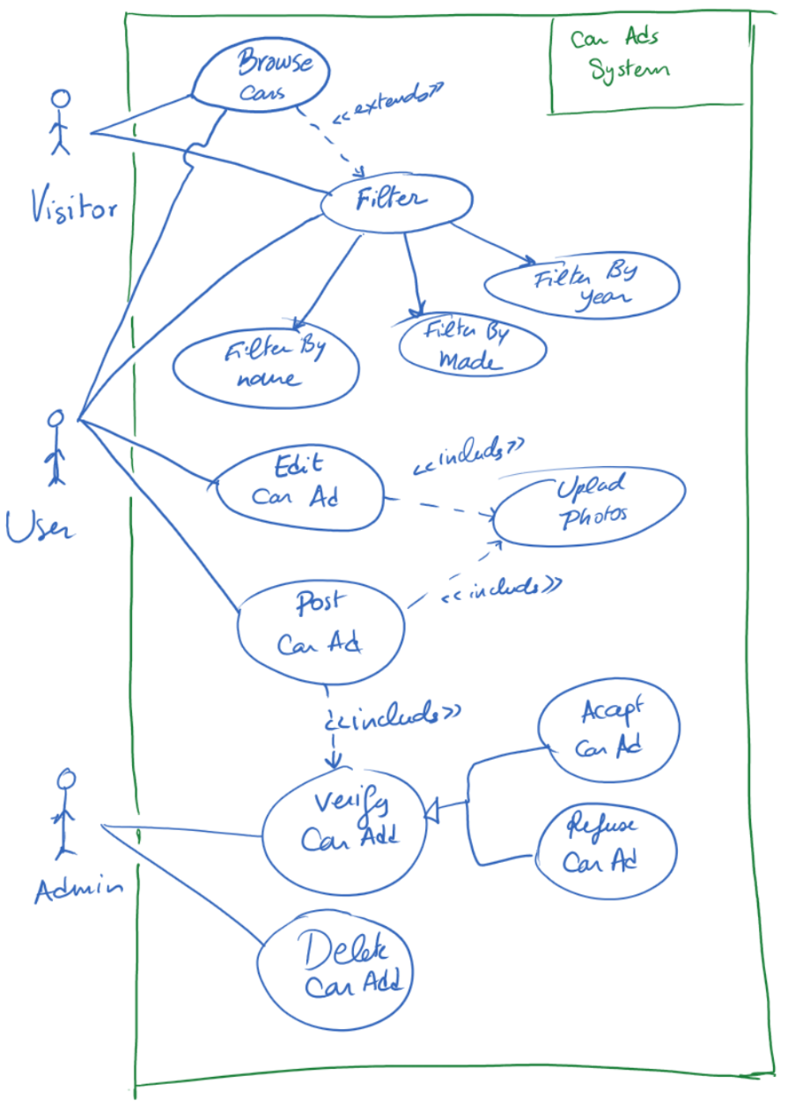

1. Based on the following additional system description, **give the textual description of the use case** “Post CarAd”.

To post a car ad, the user must fill in its name, made, body color and manufacturing year. The given year cannot exceed the current year when posting the ad. Then, the user enters the engine details such as the number of cylinders, rpm limit and max speed. Afterwards, the user enters the car identification information, namely a plate number and letter (B, G, T…) to help other visitors to track the car speed tickets, and the chassis number to allow them to check its Carfax (car history). Optionally, the user may upload one or more photos of her/his car, up to 5 maximum. After each uploaded photo, the user is asked whether s/he wants to upload another photo or terminate the upload process.

# Cash register

The normal operation of a cash register system is as follows:

A customer arrives at the checkout with items.

The cashier records the identification number of each item and the quantity if it is greater than 1.

The cash register displays the price of each item and its wording.

When all items have been registered, the cashier signals the end of the sale.

The cash register displays the total purchases.

The customer chooses his method of payment:

1. Cash: the cashier cashes the money and the cash register indicates the amount to be returned to the client.
2. Check: the cashier notes the identity of the customer and the cash register prints the amount on the check.
3. Credit card: a bank terminal is part of the cash register; it transmits the request to a multi-bank authorization center.

The cash register records the sale and prints a receipt.

The cashier transmits the printed ticket to the customer.

A customer may present discount coupons prior to payment. When the payment is completed, the credit register transmits the information relating to the items sold to the inventory management system. Every morning, the store manager sets up the cashes for the day.

**Question**: Give a use case diagram for the cash register.

# Learning Management System Moodle

Let us consider the way the Learning Management System Moodle works.

There are four main user roles in the system: Guest, Student, Assistant, and Instructor. Each user role can view and download resources without a need to authenticate. All the other tasks require authentication. The instructor can, via Moodle, create and correct assignments for students (QCM or/and Direct Questions) and fill their grades. In fact, to create an assignment, the instructor provides a mandatory assignment name, and optional description and one or more attachments. S/he specifies an assignment availability starting date and time, a submission deadline date and time, after which submitted assignments are marked as “late”, and a cut-off date and time after which the submissions are not possible at all. If s/he wants to, s/he may opt to assign the work to a specific group of students only. Otherwise, it is assigned to the whole class. At the end, the assignment is created, a notification is sent to the students and added to the calendar view of the course.

Students can upload assignments to be corrected by the Instructor, download resources and consult her/his grades. The assistant can create two types of accounts: instructor accounts and student accounts. The account creation is completed when the student/instructor receives an email and confirms the registration.

**Identify and correct** 4 pitfalls in the use case diagram that is intended to capture the above Moodle system, and that is given on the next page.

